**1.create a directory ‘project_dir’ & cd to ‘project_dir’**

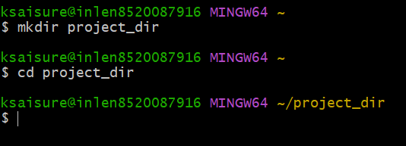

**2.Initialize git version database**



**3.Create a new file index.html**

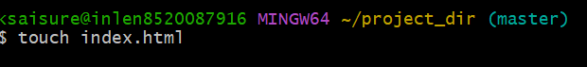

**4.Check the git status. you should find index.html as untracked file.**

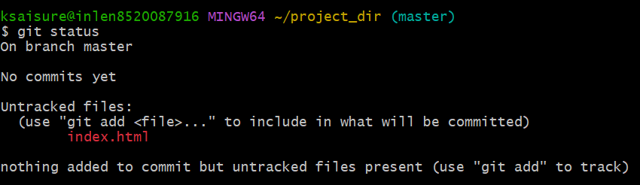

**5.Stage the index.html file.**

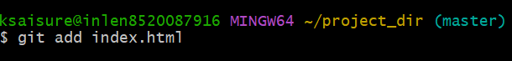

**6.Commit index.html.**

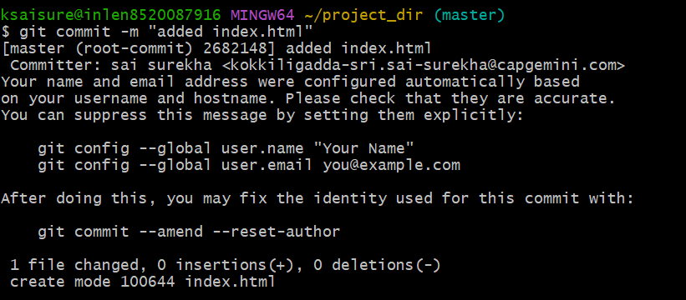

**7.Make few changes in index.html & create a new file into.txt file.**

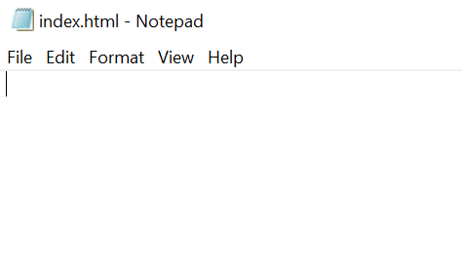

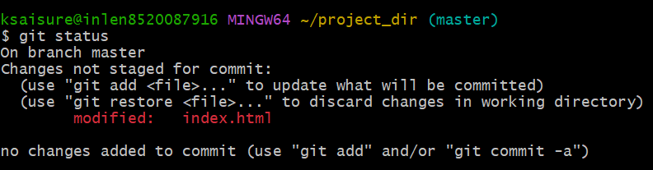

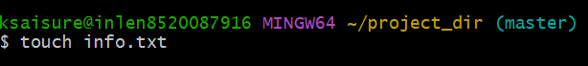

**8.Check git status. you should find index.html & create a new file into.txt file**

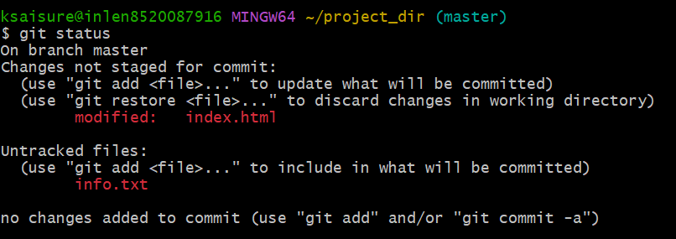

**9.configure git to ignore all txt files**



**10.Again check the git status. You should find only index.html as untracked file**

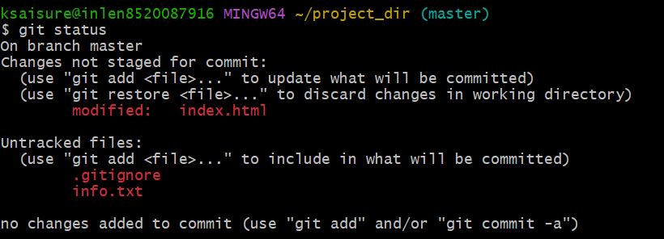

**11. State & commit**

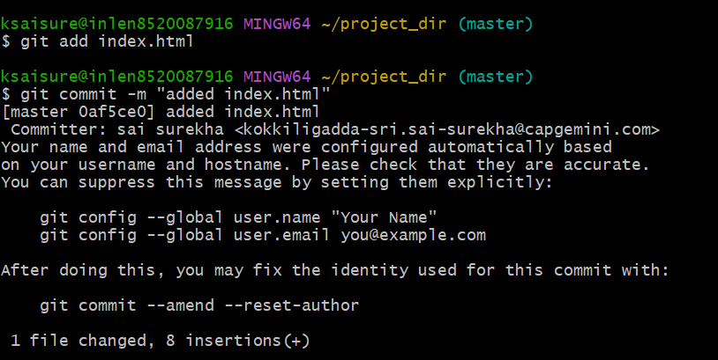

**12.log all your comments to far**

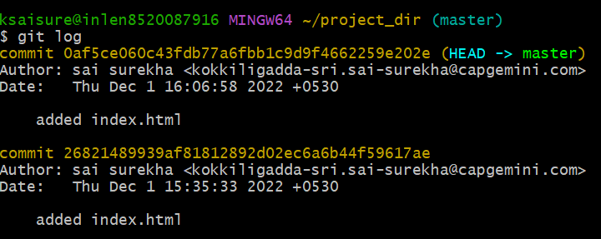

**13.make some changes in index.html**

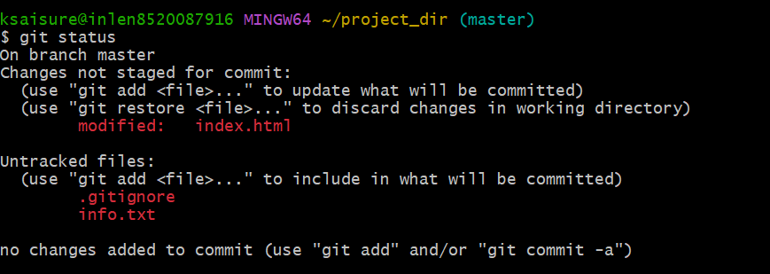

**14.Revert the changes made in the previous step using get command**

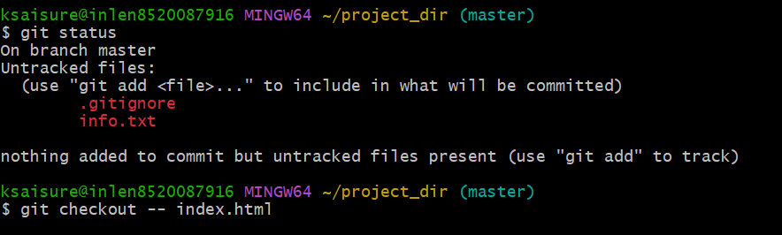

**15.Again change index.html.**

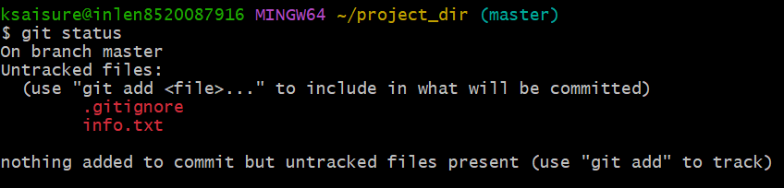

**16.Stage index.html.**

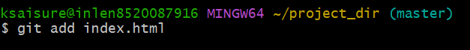

**17.Revert back the last stage**



**18.rename add command to my add.**

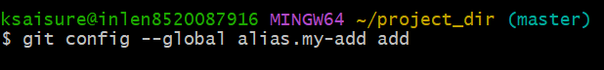

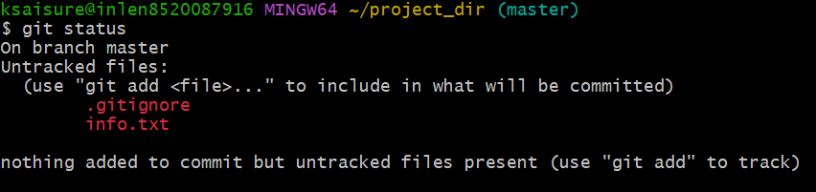

**19.Using my .add- command stage index.html again and commit the changes**

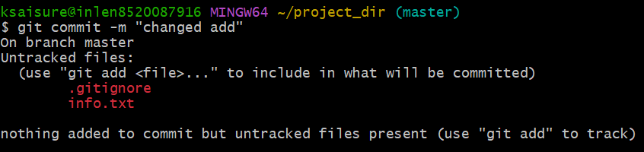

**20.Revert the last commit**

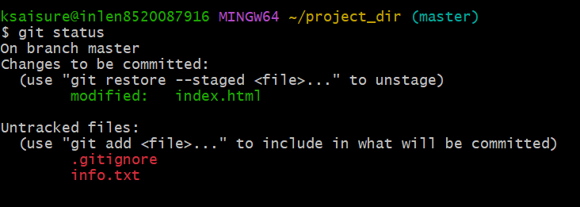

**22.create an empty directory ‘Assignments’ and cd to ‘assignments’**

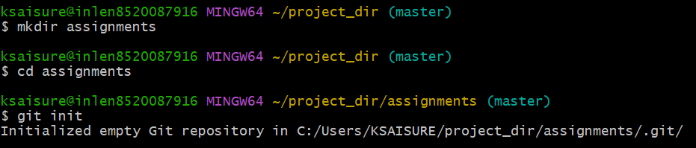

**23. create an empty directory ‘Assignments’ and write few lines about the contents of ‘assignment folder’**

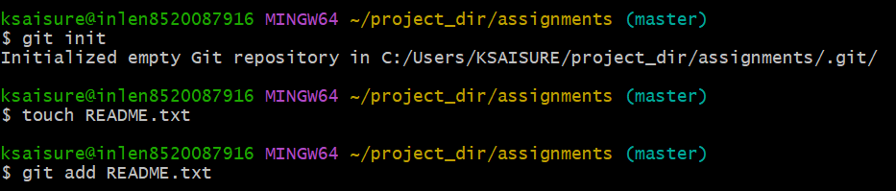

**24.commit README.txt file**

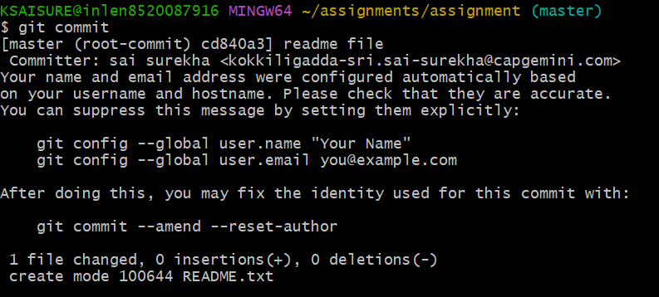

**25.now create the new branch ‘html-assignments’**



**26.switch to ‘html-assignments’ branch**

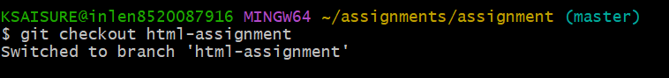

**27.copy all html assignments inside- ‘assignments’ folder.**

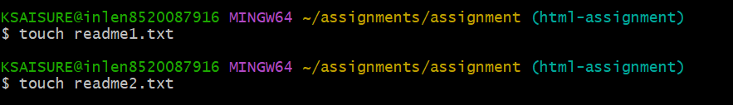

**28.commit html assignments into ‘html-assignments’ branch**

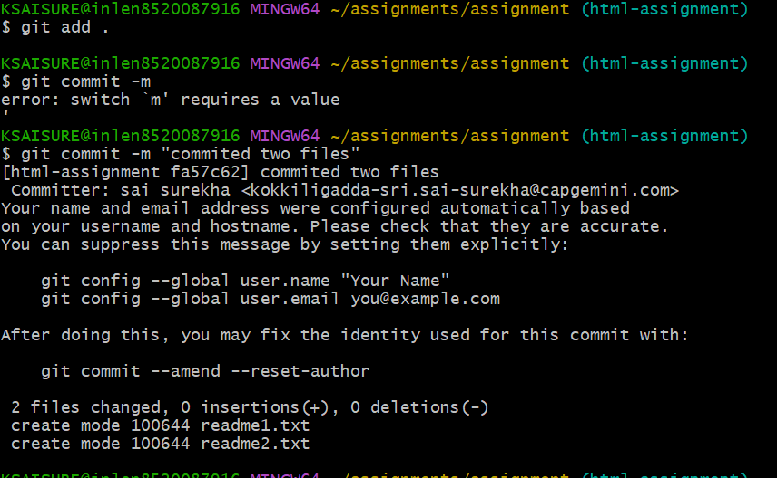

**29.make minor changes into few files belonging to ‘html-assignments’ branch**



**30.commit those changed files**

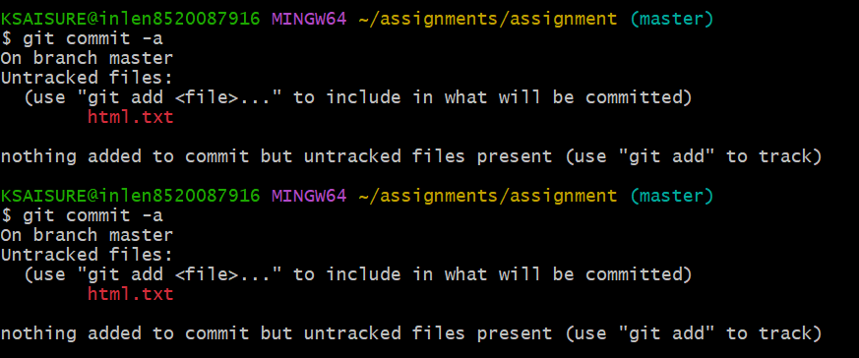

31.switch to master sheet

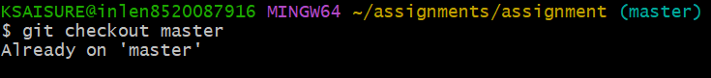

32.make minor changes into README.txt file & commit those changes into master

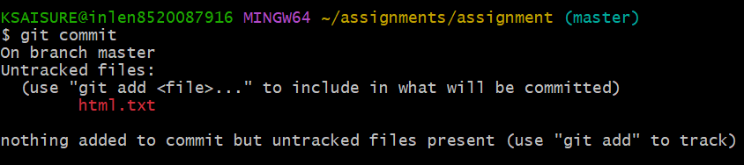

33.again switch to ‘html-assignments’ branch

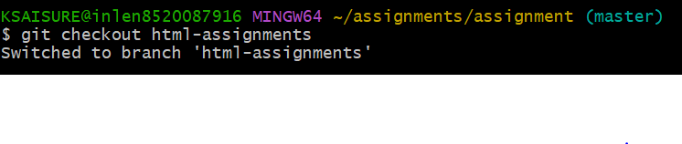34.make minor changes into few files belonging to ‘html-assignments’ branch.

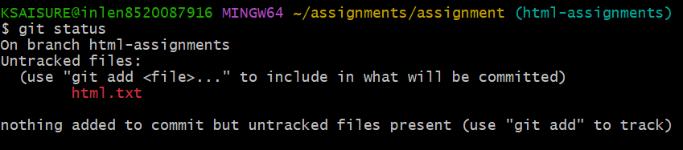

35.commit those changes

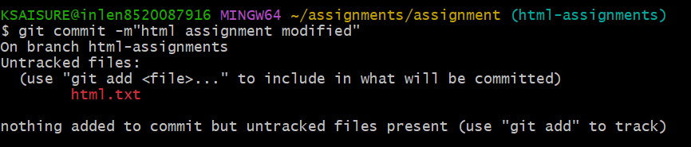

36.switch to master sheet

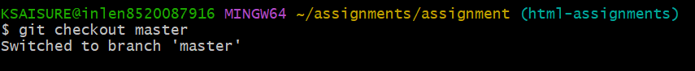

37.merge ‘html-assignments’ branch into master. confirm all html-Assignments are shown in master

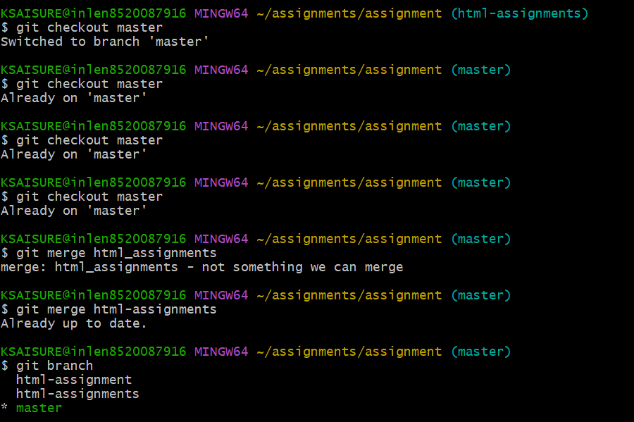

38.finally delete the ‘html-assignments’branch.

